AI Assisted Coding
Name:K.Srinija
Htno:2303A52474
Batch : 39
8.1
1.Generate at least 3 assert test cases for is_strong_password(password).
Requirements: Minimum 8 characters, must include uppercase, lowercase, digit, special character, and no spaces.
Code:
import re
def is_strong_password(password):
if len(password) < 8:
return False
if " " in password:
return False
if not re.search(r"[A-Z]", password):
return False
if not re.search(r"[a-z]", password):
return False
if not re.search(r"[0-9]", password):
return False
if not re.search(r"[!@#$%^&*(),.?\":{}|<>]", password):
return False
return True
# AI Generated Assert Tests
assert is_strong_password("Abcd@123") == True
assert is_strong_password("abcd123") == False
assert is_strong_password("ABCD@1234") == False
# User Input
print("---- Password Strength Validator ----")
user_password = input("Enter password: ")
if is_strong_password(user_password):
print("Strong Password ")
else:
print("Weak Password ")
print("All Tests Passed ")
output:
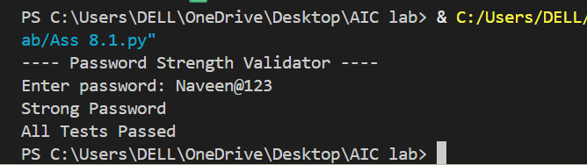
2. write a python program least 3 assert test cases for classify_number(n) to classify Positive, Negative, or Zero. Handle invalid inputs like strings and None. Use loops.
Code:
def classify_number(n):
if not isinstance(n, (int, float)):
return "Invalid Input"
for _ in range(1): # Loop usage
if n > 0:
return "Positive"
elif n < 0:
return "Negative"
else:
return "Zero"
# AI Generated Assert Tests
assert classify_number(10) == "Positive"
assert classify_number(-5) == "Negative"
assert classify_number(0) == "Zero"
assert classify_number("abc") == "Invalid Input"
# User Input
print("---- Number Classification ----")
user_input = input("Enter a number: ")
try:
number = float(user_input)
print("Result:", classify_number(number))
except:
print("Result:", classify_number(user_input))
print("All Tests Passed ")
output:
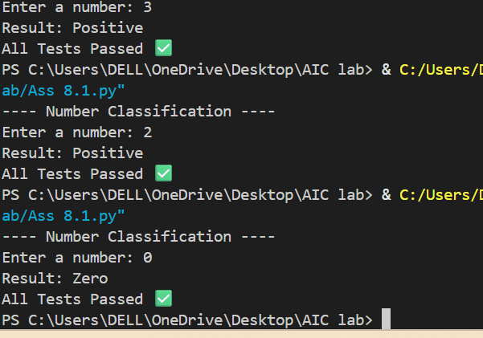

3. write a python program least 3 assert test cases for is_anagram(str1, str2). Ignore case, spaces, and punctuation. Handle edge cases.
Code:

def is_anagram(str1, str2):
def clean(s):
return ''.join(ch.lower() for ch in s if ch.isalnum())
return sorted(clean(str1)) == sorted(clean(str2))
# AI Generated Assert Tests
assert is_anagram("listen", "silent") == True
assert is_anagram("hello", "world") == False
assert is_anagram("Dormitory", "Dirty Room") == True
# User Input
print("---- Anagram Checker ----")
str1 = input("Enter first string: ")
str2 = input("Enter second string: ")
if is_anagram(str1, str2):
print("They are Anagrams ")
else:
print("They are NOT Anagrams ")
print("All Tests Passed ")

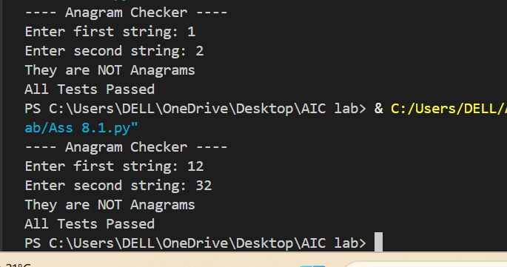

4. write a python program at least 3 assert-based test cases for an Inventory class with methods add_item(), remove_item(), and get_stock(). Implement stock management and take user input.
Code:
class Inventory:
def __init__(self):
self.stock = {}
def add_item(self, name, quantity):
if name in self.stock:
self.stock[name] += quantity
else:
self.stock[name] = quantity
def remove_item(self, name, quantity):
if name in self.stock and self.stock[name] >= quantity:
self.stock[name] -= quantity
else:
print("Not enough stock or item not found.")
def get_stock(self, name):
return self.stock.get(name, 0)
# AI Generated Assert Tests
inv_test = Inventory()
inv_test.add_item("Pen", 10)
assert inv_test.get_stock("Pen") == 10
inv_test.remove_item("Pen", 5)
assert inv_test.get_stock("Pen") == 5
inv_test.add_item("Book", 3)
assert inv_test.get_stock("Book") == 3
print("---- Inventory Management ----")
inventory = Inventory()
while True:
print("\n1. Add Item")
print("2. Remove Item")
print("3. Check Stock")
print("4. Exit")
choice = input("Enter choice: ")
if choice == "1":
name = input("Enter item name: ")
qty = int(input("Enter quantity: "))
inventory.add_item(name, qty)
print("Item added successfully.")
elif choice == "2":
name = input("Enter item name: ")
qty = int(input("Enter quantity: "))
inventory.remove_item(name, qty)
elif choice == "3":
name = input("Enter item name: ")
print("Available Stock:", inventory.get_stock(name))
elif choice == "4":
break
else:
print("Invalid choice.")
print("All Tests Passed ")
output:
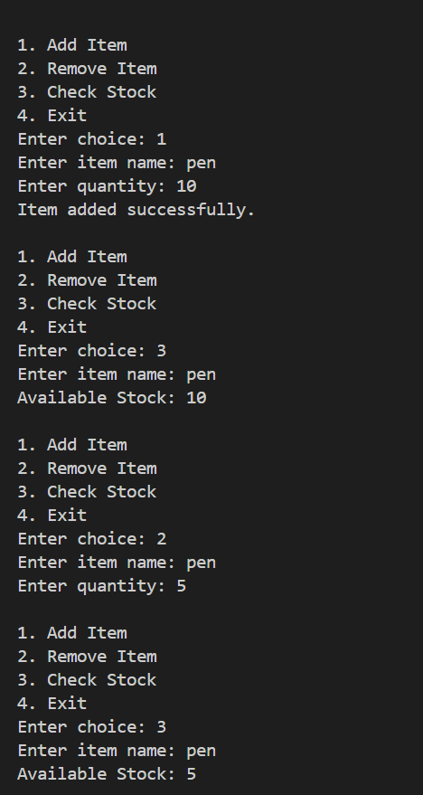
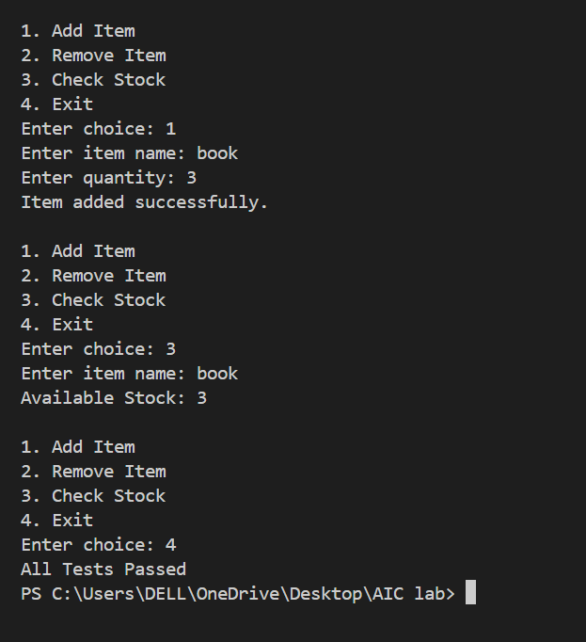5. Write a python code at least 3 assert test cases for validate_and_format_date(date_str) to validate "MM/DD/YYYY" format, handle invalid dates, and convert to "YYYY-MM-DD".
Code:
from datetime import datetime
def validate_and_format_date(date_str):
try:
date_obj = datetime.strptime(date_str, "%m/%d/%Y")
return date_obj.strftime("%Y-%m-%d")
except:
return "Invalid Date"
# AI Generated Assert Tests
assert validate_and_format_date("10/15/2023") == "2023-10-15"
assert validate_and_format_date("02/30/2023") == "Invalid Date"
assert validate_and_format_date("01/01/2024") == "2024-01-01"
# User Input
print("---- Date Validation ----")
user_date = input("Enter date (MM/DD/YYYY): ")
print("Result:", validate_and_format_date(user_date))
print("All Tests Passed 2")
output:
